SmartCoDe Demonstrator  Objectives | 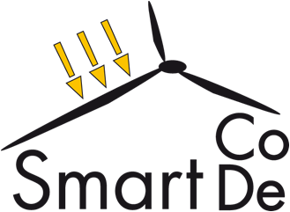
Lotusgasse 9
3040 Almersberg
Austria
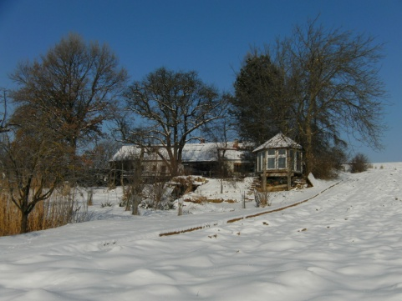

Revision: | 02
Date: | 28/07/2026
Name: | C. Wysoudil, F. Schmidt
 | © ennovatis GmbH 2010

Contents

1 Introduction 3
2 Basic information on the demonstrator 4
3 Overview of planned and installed LEP and EUP 6
3.1 Components of the demonstrator 6
3.2 Smartbox Channel overview - meters and sensors 7
3.3 Splan documentation of the demonstrator 8
4 SmartCoDe planned actions and expected impact 9
4.1 Consumption awareness at low additional costs 9
4.2 Consumption Reduction using ultra-low power / small size integrated circuits 9
4.3 Communication infrastructure 9
4.4 Communication Security 9
4.5 Impact of actions planed and refinement of models and demonstrator 9
4.5.1 Show the benefits of EM before SmartCoDe 10
4.5.2 Show the benefits of EM after SmartCoDe 10
4.5.3 Impact of various energy supplying systems 11
4.5.4 Automated control of EuPs using the SmartCoDe devices 11
4.5.5 Automated energy management 11
4.5.6 Demonstration of technical and economic feasibility and benefits of intelligent energy management 11
4.5.7 Quantification of possible energy savings 12

Introduction
The objective of SmartCoDe is to enable the application of advanced techniques for energy management in private and small commercial buildings and neighbourhoods.
This will be essential, because future buildings and neighbourhoods are expected to combine a manifold of Energy using Products (“EuP”) ranging from electrical lighting to HVAC with locally available renewable energies (e.g. solar, wind) and with locally available storages (e.g. car batteries). The energy in such a local grid has to be distributed in an intelligent way in order to enable customers to participate in the energy market and even contribute to the stability of the power grid. SmartCoDe will lead to an adequate energy management with a fine grained infrastructure and powerful hardware.
The project will fulfil its goals by
- Developing new methods for automated energy management that specifically considers the requirements of Energy using Products in homes / offices and local renewable energy providers, considering the required information security and dependability.
- Developing an inexpensive hardware/software implementation that can be integrated into arbitrary Energy using Products, providing them with the ability to communicate and to remotely control its use of power.
- Demonstration of technical and economic feasibility and benefit of intelligent energy management in buildings and neighbourhoods with an initial focus on electric lighting.
If successful, the project will allow all manufacturers of EuP to add energy management functionality (and maybe additional features such as remote control, etc.) for very little additional cost, and thereby address a new and huge market in homes and offices. The local energy management will enable local entities to participate in the energy market as an intelligent, managed “sub-grid” that can – if necessary – even contribute to a demand side management and thereby reducing the required “spinning reserve”.
The demonstrator will therefore combine basic energy management and control functionalities with
- local energy production (LEP) by renewable energies and
- energy using products (EUP) as for example household appliances including various lighting systems
This will allow to consider buildings and neighbourhoods as smart local grids which can become partners in the energy market and even contribute to the stability of the power grid
Generally the demonstrator will be used to
• Show the benefits of classical EM
• Show the benefits of high resolution EM (intelligent metering)
• Control with the impact of various energy supplying systems
(open building automation system)
• Implementation of new developed methods for automated energy management
• To communicate and to remotely control EuPs using the SmartCoDe devices
• Demonstration of technical and economic feasibility and
benefit of intelligent energy management
• Quantify possible energy savings due to
- Classical energy management
- High resolution energy management
- Coordination of supply systems
- Coordination of energy using products
- Reduction of peak load

Basic information on the demonstrator
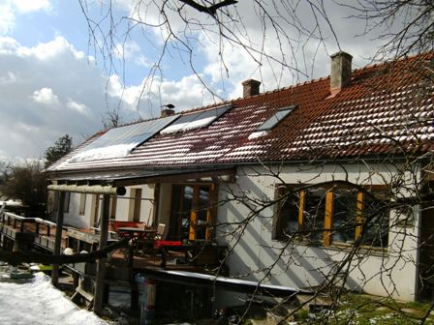 |  | 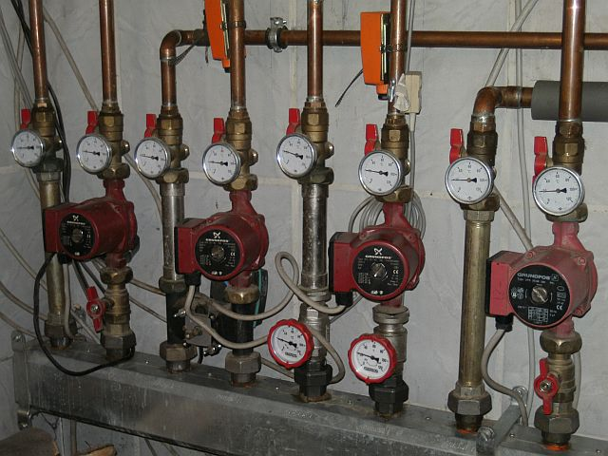
Figure 1 Building with photovoltaic |  | Figure 2: Heating system
 | location: |  | A- 3040 Almersberg, Austria
 | Altitude |  | 48.20°
 | Longitude |  | 15.92°
 | Sea Level |  | 250 m
 | wheather data: avarage outdoor temp. |  | 11 °C
 | year of construction, refurbishment: |  | 1901 / 1928 / 1993
 | net base area: |  | 718 m²
 | gross floor area: |  | 836 m²
 | Net base area (thermal) |  | 537 m²
 | Ve (thermal gross volume) |  | 1.266 m³
 | A (surface area) |  | 2.840 m²
 | A/V |  | 2,24 m -1
 | BRI (gross volume) |  | 1.955 m³
Table 1 Basic Information on the Demonstrator
The following table gives an overview of the consumption of energy of the last 5 years.

medium period | 2005 | 2006 | 2007 | 2008 | 2009
gas [kWh] | 2.306 | 837 | 326 | 339
electricity pub supply [kWh] 04 -03 | 10.609 | 10.776 | 10.030 | 5.771
electricity sold to pub grid [kWh] | 0 | 0 | 0 | 0
electricity production PV [kWh] | 0 | 0 | 0 | 0 | 4.510
warm water [m³] | No data | No data | No data | 98 | 82
heating [kWh] | 18.240 | 16.416 | 14.592 | 12.768 | 0
Table 2 Consumption data of demonstrator side
Remarks
General: The measuring period is fixed from April to March of the next year
Gas consumption: Gas is only used in winter period for an anti frost strategy during holidays app. 4 to 5 weeks and was installed first time in 2005.
Electricity consumption: in 2008 the heating pumps where switched of after April, the e-Boiler was renewed and the temp reduced and the 3 PCs where switched of when not in use – also the old deep freezer was exchanged to a high efficient working deep freezer..
Electricity production: the photovoltaic was installed in the year 2009
Warm Water: the water counter was installed at the entry for the solar boiler in 2008.
Heating: 4 circles with floorheating and radiators are used – main source hardwood 0,5 meter pieces.
This leads to heat consumption of 24,41 kWh/m²/a and an electricity consumption of 10.7 kWh/m²/a which is according to Austrian standard way in the category of a “Niedrigenergiehaus” standard.
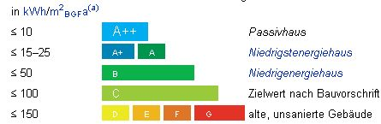

Figure 3: Result operational rating according to Austrian standards

The running costs during the last 5 years for heating, electrical energy, water and waste water:
medium period | 2005 | 2006 | 2007 | 2008 | 2009
 | Euro | Euro | Euro | Euro | Euro
gas, water, electricity | 2.365 | 2.344 | 2.305 | 1.126
cost reduction based on 2005 | 0 | 1% | 3% | 52%
Table 3: running energy costs on the demonstrator
The costs are basically due to the electricity consumption. The reductions are due to the described analyses of consumption and user behaviour. The first attempted started as seen above in the year 2008 with the energy cost reduction based on the year 2005 of 52%.

Overview of planned and installed LEP and EUP
Consumption and production is measured by the main gas meters, main electric meter and two water meters. The following figures and tables give an overview of LEP, EUP and the installed and planned data channels.

Components of the demonstrator
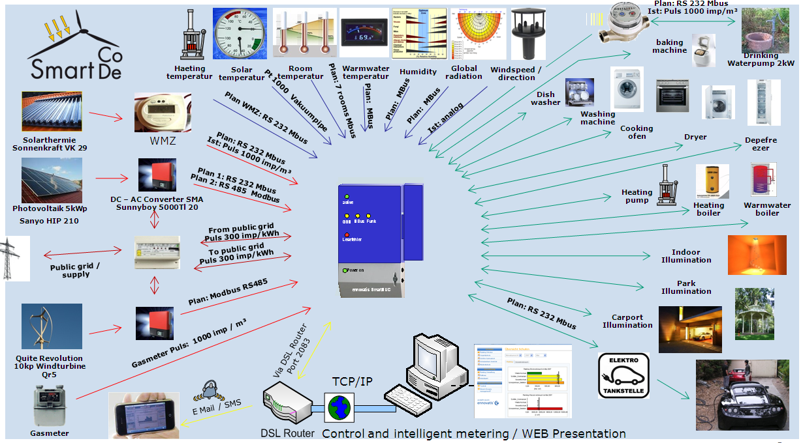
Figure 4: Demonstrator overview of available combinations of LEP and EUP

Local energy production (LEP) | kW |  | Energy using products (EUP) | kW
Solar Heating Vacuum tubes | 1,2 |  | Fridge | 0,05
Windpower generator | 10 |  | Deep Freezer | 0,12
Photovoltaic | 4 |  | Water pump Gardening | 0,22
 |  |  | Heating pump | 0,045
Supply from public grids |  |  | Illumination | 4,5
public grid supply gas | 35 |  | Indoor
public grid supply Electric Power | 25 |  | Car Parking
local water supply | 2 |  | Outdoor (Park, Terasse)
 |  |  | Water heater electrical | 2
 |  |  | Washing machine | 2
Energy storage |  |  | Dishwasher | 2
Battery 24V / e-car power supply |  |  | Watersupply pump | 2
Room Heating Watertank 1 800l | 2 |  | Circulation pumps | 0,25
WW Watertank 2 400l |  |  | Cooking | 3,6
WW Watertank 3 100l | 2 |  | Baking machine | 2
Watertank 4 500l | 2
Additional measurements
Temperatures (see table ) |  |  | Metrological data (see Tab.)
Table 4: Overview of connected power on the demonstrator

Smartbox Channel overview - meters and sensors
The EMS will get via Smartbox the following information through meters and sensors:
Already activated channels
Name | A | M | TE | MC | U | SC | ID
Energy supply
Gas counter | 5 | Gas | m³ | 15 | Min | 0 | 1
Electricity from pubic grid | 3 | el. cur 3phase | kWh | 15 | Min | 0 | 2
Electricity to pubic grid | 2 | el. cur 1phase | kWh | 15 | Min | 0 | 3
WW counter | 6 | water | l | 15 | Min | 10 | 9
Solar counter | 7 | solarwater | l | 15 | Min | 0 | 10
T Temperatures
T Outdoor west terasse | 0 | Air | °C | 15 | Min | 5 | 6
T Solar RL | 4 | solarwater | °C | 15 | Min | 15 | 11
T Solar VL | 5 | solarwater | °C | 15 | Min | 15 | 12
T Warm Water | 6 | freshwater | °C | 15 | Min | 15 | 13
T Solar Thermie roof | 2 | solarwater | °C | 15 | Min | 5 | 5
T Cold Water | 3 | freshwater | °C | 15 | Min | 5 | 7
T Solarwatertank up 400l | 7 | freshwater | °C | 15 | Min | 15 | 14
Other sensors
Wind m/s | 4 | wind | m/s | 10 | Min | 60 | 8
shorttime planning
Global radiation |  | sun | w/m2 | 15 | Min | 60
Wind direction |  | wind | ° | 15 | Min | 10
Temperature PV Surface |  | Temperature | °C | 15 | Min | 60
Temperature WW El.tank 100l |  | Temperature | °C | 15 | Min | 15
Watertank 3 100l (WW) |  | electricity | kWh | 15 | Min | 0
Electricity production LEP (PV) |  | electricity | kWh | 15 | Min | 0
Various appliances (EUPs) |  | on/off switch
further planning
Local Energy Production (LEP)
Windpower generator |  | electricity | kWh
Photovoltaic / Modbus |  | electricity | kWh
Solarthermie |  | Water | kWh
Biomass |  | Water | kWh
Gas (BHKW) ? |  | Gas | m³
public Electric Power Supply |  | Co2 emission | to
Energy using Products (EUP)
Fridge |  | electricity | kWh
Deep Freezer |  | electricity | kWh
Water pump Gardening |  | electricity | kWh
Heating pump |  | electricity | kWh
Illumination 1 |  | electricity | kWh
Illumination 2 |  | electricity | kWh
Illumination 3 |  | electricity | kWh
Water heater electrical |  | electricity | kWh
Washing machine |  | electricity | kWh
(Aircondition) |  | electricity | kWh
Dishwasher |  | electricity | kWh
Watersupply pump well |  | electricity | kWh
Cirulationpumps Solarthermie |  | electricity | kWh
Cooking |  | electricity | kWh
Baking mashine |  | electricity | kWh
Battery loading station) |  | electricity | kWh
Watertank 1 800l cent heating |  | electricity | kWh
Watertank 2 400l (WW) |  | electricity | kWh
Watertank 4 500l (WW) |  | electricity | kWh
used abbreviations
 | A | Channel number
 | M | Medium
 | TE | technical entity
 | MC | Measuring Cycle
 | U | Measuring Cycle Units
 | SC | Storage Cycle Units
 | ID | ChannelI D
Table 5: overview of the EMS channels

Splan documentation of the demonstrator
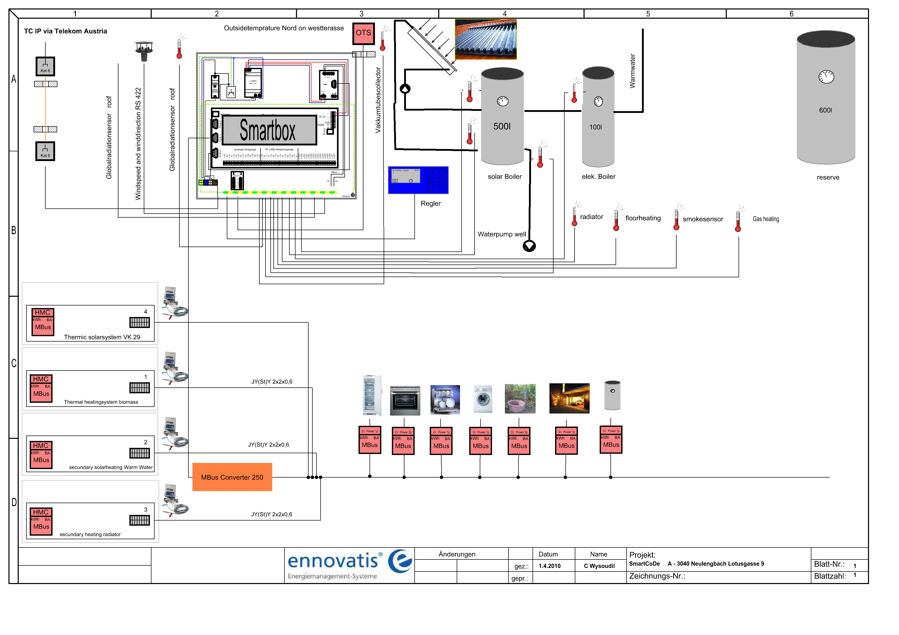
Figure 5: Demonstrators Structure Plan

SmartCoDe planned actions and expected impact
The demonstrator will be used to prove the following results of the SmartCoDe project

Consumption awareness at low additional costs
We will calculate the costs of a full installation and compare it with prices of solutions before SmartCoDe with similar functionality
We describe the costs of each additional data channel
We compare costs against energy savings and calculate simple payback times. Low cost: payback time must be less than 3 years.

Consumption Reduction using ultra-low power / small size integrated circuits
The demonstrator will use the newly developed chips where ever possible. Thus we shall get experiences how to integrate the chip and how it will influence the various appliances

Communication infrastructure
The communication infrastructure will be described by a schematic of all LEP / EUP with the Smart Control and by graphics of the recorded data transmitted from the LEPs and EuPs to the Smartbox.

Communication Security
We will contribute to the practical part of the security testing. We will supplement the formal part. It will be required because some kind of bugs are hard to find during practical testing and it is also important to ensure that somebody took into account possible threats.
To do this we will allow trials to break security by attacks for the search of security holes in the demonstration system.
The formal part will contain
- threat analysis (report discussing each of the threats and how they may be neutralized + what the options are for achieving an effective security solution)
- risk assessment (probability and consequences of attacks)
- formal audit of design (e.g. if it handles well known threats)
- formal audit of implementation (e.g. if it matches design, if algorithms are well implemented, if there aren't any backdoors, etc)
These steps are defined in methodology which is used for development of secure product.
The practical part will contain
- penetration testing with people not involved in implementation
- trials to break security by using own checklist for attacks for the search of security holes in system.

Impact of actions planed and refinement of models and demonstrator
The newly developed technologies of the SmartCoDe project can be applied most profitable in connection with an intelligent and cost-effective energy management system. This will lead to substantial improvements of Energy Management (EM). To demonstrate these new features is the main purpose of the demonstrator. We will do this in 7 steps:

Show the benefits of EM before SmartCoDe
- Show the benefits of classical EM
- Show the benefits of high resolution EM (intelligent metering)
- Control with the impact of various energy supplying systems
(open building automation system)
- Quantify possible energy savings due to
  - Classical energy management
  - High resolution energy management
This will be done by producing a series of energy reports which describe the various stages of the demonstrator
Report 1 (this report) describes the actual state of the demonstrator and the actual energy consumption of the demonstrator
Report 2 describes the state after introducing energy management according to the state of the art

Show the benefits of EM after SmartCoDe
- Implementation and evaluation of new developed methods for automated energy management as developed in WP 1. This will include methods from
  - Task 1.1 Model of energy using products in households and offices
  - Task 1.2 Model of local energy provider
  - Task 1.3 Energy Generation Forecasting
  - Task 1.4 Demand side management in local grids
  - Tasks 1.5 Power management
- To communicate and to remotely control EuPs using the SmartCoDe devices
- Demonstration of technical and economic feasibility and benefit of intelligent energy management
- Quantify possible energy savings due to
  - Coordination of supply systems
  - Coordination of energy using products
  - Reduction of peak load
This will be done by producing semi annual energy reports which describe the various stages of the demonstrator
Report 3 describes energy management after integrating LEP into the local grid
Report 4 describes energy management after integrating EUP into the local grid
Report 5 will summarize our findings and describe the lessons learned

As a result of this R&D project we will be able to trace the consumption of the EUPs in real time intervals and to develop typical usage profiles. This is the basic information necessary for Smart automated EMS.
Also it will be possible to analyze the performance of the EUP in dependence of events. (eg. the person is sitting down on the chair in front of the computer, the PC screen is switching on – or the tariff for energy is changing at 2 pm and the EUP xy will be switched on [or off] or the light will be dimmed)

Impact of various energy supplying systems

For the energy supply companies it is a standard to observe and control production and distribution of energy. For household and small neighbourhood solutions the use of EUP will be in dependence of the LEP, of rates (tariffs), may be of the CO₂ emissions of the supplier and so on.

The demonstrator will be used to show the influence of local produced renewable energy in the household:
- dependence of in- and decrease of wind
- dependence of in- and decrease of global radiation
- changes of energy rates from the supplier
- changes of energy selling rates to the public grid

The EUPs being time flexible in a certain range of time for the performance time will be shifted to optimized EMS Solutions. (eg. the trash hold value of the production of solar- or wind power is reached – the electric car will be charged).

According to the goals of the optimization model different benefits are the follow up effect – eg.:
- Cost reduction for buying energy from the public grid
- Load reduction for energy out of the public grid
- Peak load reduction for energy out of the public grid
- CO₂ reduction of the public production (eg in peak load situations)

For solutions with storages the local “access production” will be used in an optimized way in the own storage system.
The measure to evaluate the results will be the increase of the efficiency of energy use of the LEPs

Automated control of EuPs using the SmartCoDe devices
The automated control of the EUPs will be performed with the Smartbox and later with the Smartcenter. The Smartcenter is a taylorable form of the Smartbox. It contains modules for EuP control (rule and tariff based) and wireless communication. The communication with the Integrated Circuit Solution of SmartCoDe will be possible. ( Smart EUP Control with Integrated Circuit Solution: “ SEC”).
The test will include 3 functions of the SEC :
- Switching on and off
- Dimming (eg Illumination)
- Frequency control (eg heating Pump)
The automated control will include for the basic decisions 3 functions of the SEC:

- Manual interaction of the user
- Rule based control
- Tariff based control

Automated energy management
For the automated energy management we will investigate 2 optimization scenarios:
- Maximize of the local use of the local produced energy
- Maximize the benefit by selling the LEP to the public grid.

Demonstration of technical and economic feasibility and benefits of intelligent energy management
We will demonstrate the technical and economic feasibility by providing
- Monitoring via Webinterface
- User interface with TouchScreen interaction

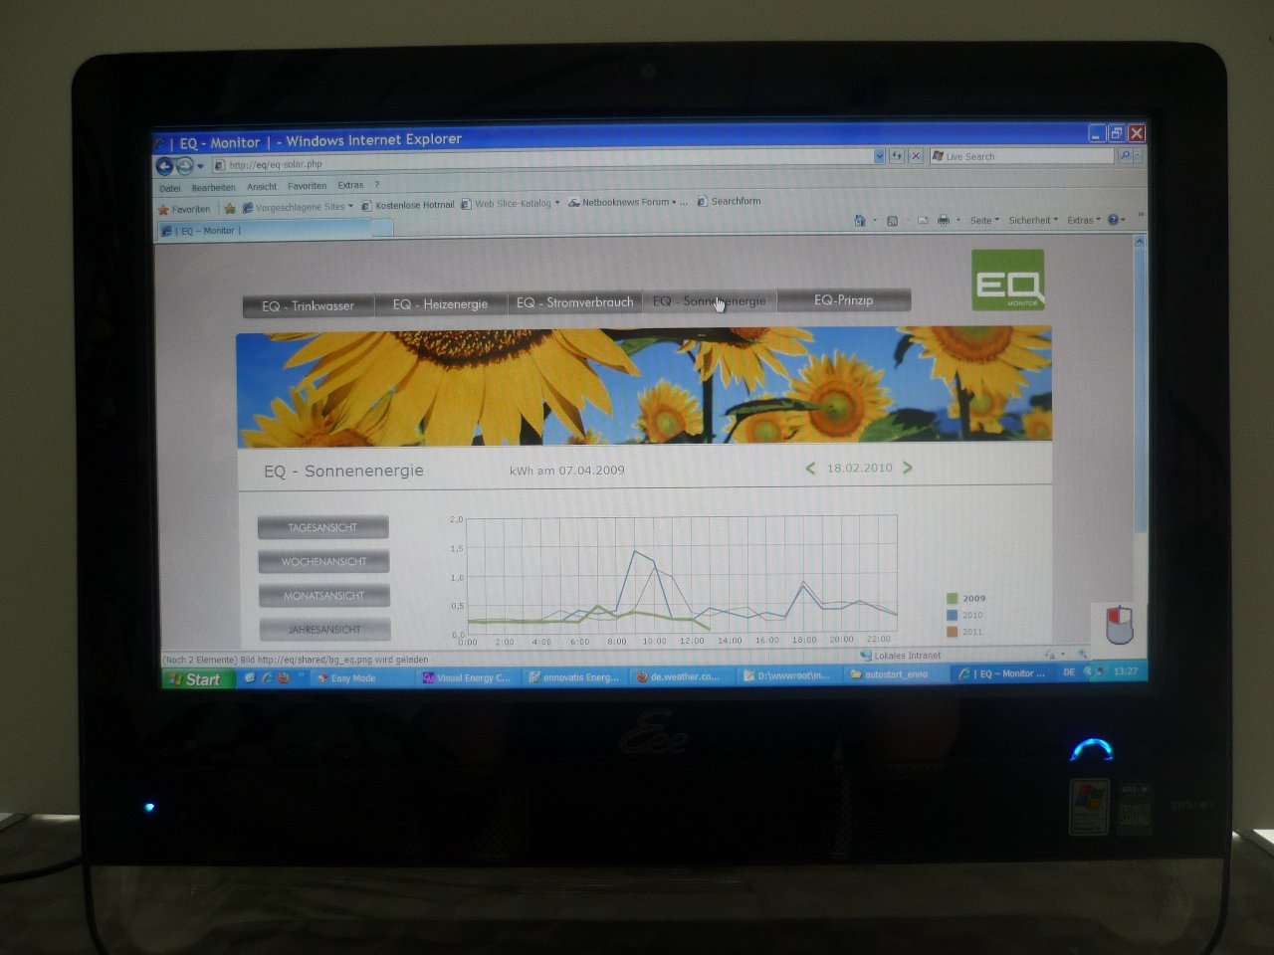

Figure 6: User interface with Touch Screen interaction

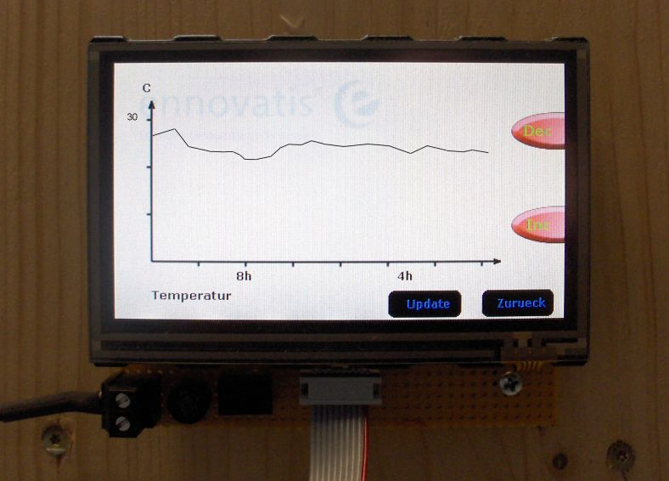

Figure 7: User interface with Touch Screen interaction Details

We will demonstrate the technical and economic benefits by providing energy reports which include
- Calculations of energy savings
- List of technical features
- Summary of advantages

Quantification of possible energy savings
Finally we will try to quantify the possible energy savings due to
- Classical energy management
- High resolution energy management
- Coordination of supply systems
- Coordination of energy using products
- Reduction of peak load

This task seems to be most ambiguous due to the fact that the demonstrator is a low energy house (Niedrigenergie Haus) anyway.

